$$Assignemnet-1$$

$$k=2 ,k=3 and k=4$$

|  |  |  |
| --- | --- | --- |
| Id | X | Y |
| 1 | 1 | 2 |
| 2 | 2 | 3 |
| 3 | 3 | 4 |
| 4 | 4 | 5 |
| 5 | 5 | 6 |
| 6 | 6 | 7 |
| 7 | 7 | 8 |
| 8 | 8 | 9 |
| 9 | 9 | 10 |
| 10 | 10 | 11 |
| 11 | 11 | 12 |
| 12 | 12 | 13 |

|  |  |  |
| --- | --- | --- |
| **Individual** | **Variable 1** | **Variable 2** |
| 1 | 1.0 | 1.0 |
| 2 | 1.5 | 2.0 |
| 3 | 3.0 | 4.0 |
| 4 | 5.0 | 7.0 |
| 5 | 3.5 | 5.0 |
| 6 | 4.5 | 5.0 |
| 7 | 3.5 | 4.5 |

|  |  |
| --- | --- |
| Cluster | WCSS |
| K=1 | 2000 |
| K=2 | 1500 |
| K=3 | 1000 |
| K=4 | 800 |
| K=5 | 700 |
| K=6 | 650 |

$$Graph between these two Cluster vs wcss$$

$$Elbow method$$

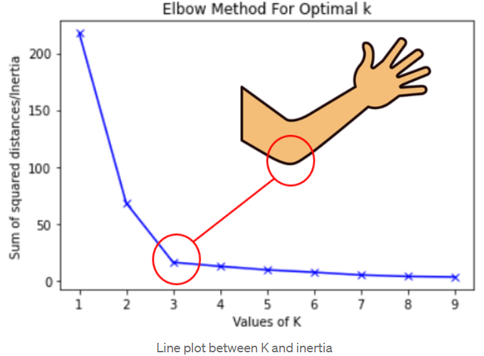

$$For k=2$$

$$Total data points are 12 divided into two clusters$$

$$First 6 points are one clusters , second 6 points are another cluster$$

$$d_{1c1}+d_{2c1}+d_{3c1}+d_{4c1}+d_{5c1}+d_{6c1}+d_{7c2}+d_{8c2}+d_{9c2}+d_{10c2}+d_{11c2}+d_{12c2}$$

$$d_{31}=distance of 3rd point with fisrt cluster centroid$$

$$d_{102}=distance betwen 10th data point with second cluster centroid$$

|  |  |
| --- | --- |
| Cluster | WCSS |
| K=2 | 70 |
| K=3 | 30 |
| K=4 | 16 |
|  |  |
|  |  |
|  |  |

$$silhouette score$$

$$SS will give the idea , the corresponding data point belongs to suitable cluster or not$$

$$Supppose we divided data points into two parts$$

$$Step-1: Randomly divide the groups based k value$$

$K=2 (Two groups)$

$$Group-1 : \left(1,2,3\right)observations$$

$\left(1,1\right) \left(1.5,2\right) (3,4)$

$$Group-2 : \left(4,5,6,7\right)observations$$

$\left(5,7\right) \left(3.5,5\right) \left(4.5,5\right),(3.5,4.5)$

$$Each data point will calculate the distance between other data point in withinthe cluster$$

$$as well as data points with other clusters$$

$$x_{1},x_{2},x_{3} are belongs to cluster-1$$

$$x_{4},x_{5},x_{6},x_{7} are belongs to cluster-2$$

$$consider x_{1} point calculate the distance with all the other data points in cluster-1$$

$$d\left(x_{1},x_{2}\right) d\left(x_{1},x_{3}\right)$$

$Now take the average of distance=$ $$\frac{\left[d\left(x_{1},x_{2}\right)+ d\left(x_{1},x_{3}\right)\right]}{2}=a$$

$$x_{1} point calculate the distance with all the other data points in cluster-2$$

$$d\left(x_{1},x_{4}\right) d\left(x_{1},x_{5}\right),d\left(x_{1},x_{6}\right) d\left(x_{1},x_{7}\right)$$

$Now take the average of distance=$ $$\frac{\left[d\left(x_{1},x_{4}\right)+ d\left(x_{1},x_{5}\right)+d\left(x_{1},x_{6}\right)+ d\left(x_{1},x_{7}\right)\right]}{4}=b$$

$$S=\frac{b-a}{\max\left(b,a\right)}$$

$$Case-1:$$

$$assume that x_{1} point belongs to cluster-1$$

$$what colud be the s value?$$

$$In this senario b value high compare to a : b≫≫>a$$

$$s=\frac{\left(b-a\right)}{b}$$

$$b-a≅b$$

$$s=1$$

$$s=1 means the corresponding data point very well clustered$$

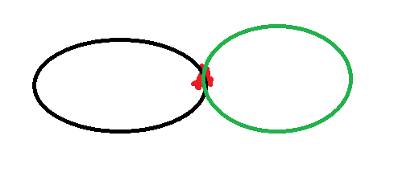

$$Case-2:$$

$$assume that x_{1} point on the border$$

$$what colud be the s value?$$

$$In this senario b equal to a : b=a$$

$$s=0$$

$$s=0 means the corresponding data point on the border$$

$$Case-3:$$

$$assume that x_{1} point belongs to cluster-1 but we place in cluster-2$$

$$x_{1} to cluster_{1}: a$$

$$x_{1} to cluster_{2}: b$$

$$S=\frac{b-a}{\max\left(b,a\right)}= -\frac{a}{a}=-1$$

$$S varies from-1 to 1$$

$$-1 means wrongly grouped$$

$on the border$

1. *Means correctly grouped*